TABLE Empl:

INSERT INTO `testdb`.`Empl` (`empno`, `ename`, `job`, `mgr`, `hiredate`, `sal`, `comm`, `deptno`)

VALUES ('8521', 'SETH', 'SALESMAN', '8698', '1990-02-22', '1250.00', '500.00',30);

INSERT INTO `testdb`.`Empl` (`empno`, `ename`, `job`, `mgr`, `hiredate`, `sal`, `deptno`) VALUES ('8566', 'MAHADEVAN', 'MANAGER', '8839', '1991-04-02', '2985.00',20);

INSERT INTO `testdb`.`Empl` (`empno`, `ename`, `job`, `mgr`, `HIREDATE`, `SAL`, `deptno`) VALUES ('8882', 'SHIVANSH', 'MANAGER', '8839', '1991-06-09', '2450.00', '10');

INSERT INTO `testdb`.`Empl` (`empno`, `ename`, `job`, `mgr`, `HIREDATE`, `SAL`, `deptno`) VALUES ('8888', 'SCOTT', 'ANALYST', '8566', '1992-12-09', '3000.00', '20');

INSERT INTO `testdb`.`Empl` (`empno`, `ename`, `job`, `HIREDATE`, `SAL`, `deptno`) VALUES ('8839', 'AMIR', 'PRESIDENT', '1991-11-18', '5000.00', '10');

INSERT INTO `testdb`.`Empl` (`empno`, `ename`, `job`, `mgr`, `HIREDATE`, `SAL`) VALUES ('8844', 'KULDEEP', 'SALESMAN', '8698', '1991-09-08', '1500.00');

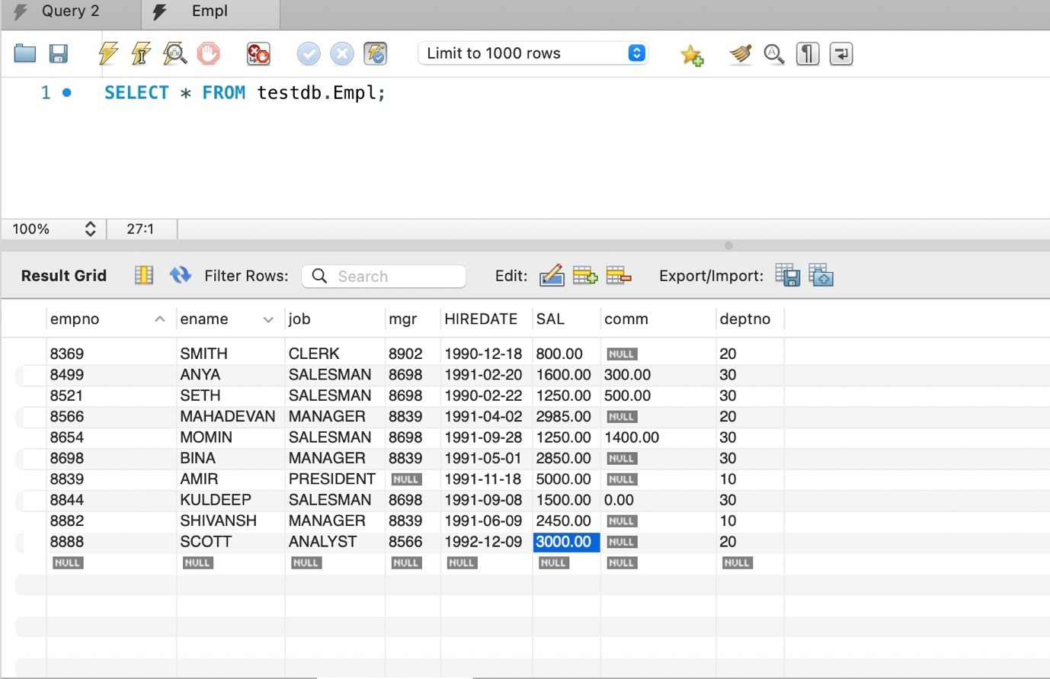

A. Write a query to display EName and sal of employees whose salary are greater than or equal to 2200?

SELECT ENAME, SAL

FROM empl

WHERE SAL > 2200;

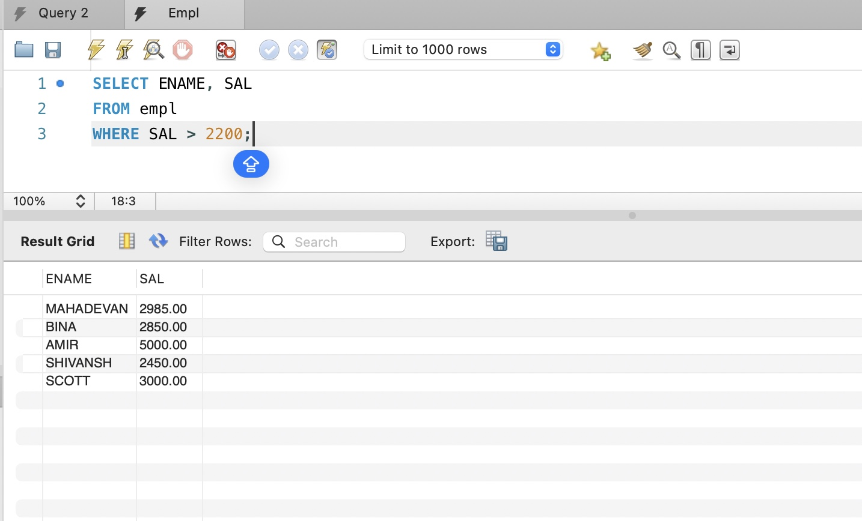

B. Write a query to display details of employees who are not getting commission?

SELECT *

FROM empl

WHERE COMM IS NULL

OR COMM = 0.00;

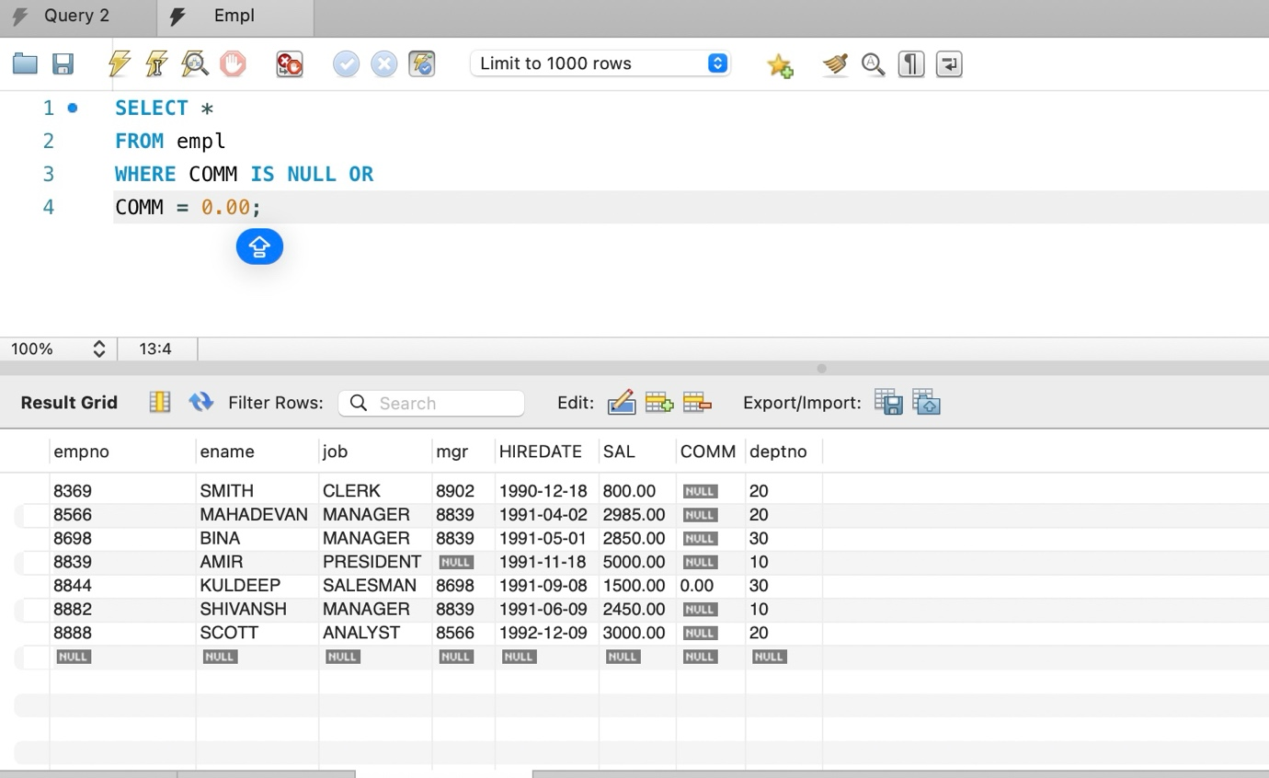

C. Write a query to display employee name and salary of those employees who don’t have their salary in the range of 2500 to 4000?

SELECT ENAME, SAL

FROM empl

WHERE SAL <= 2500

OR SAL >= 4000;

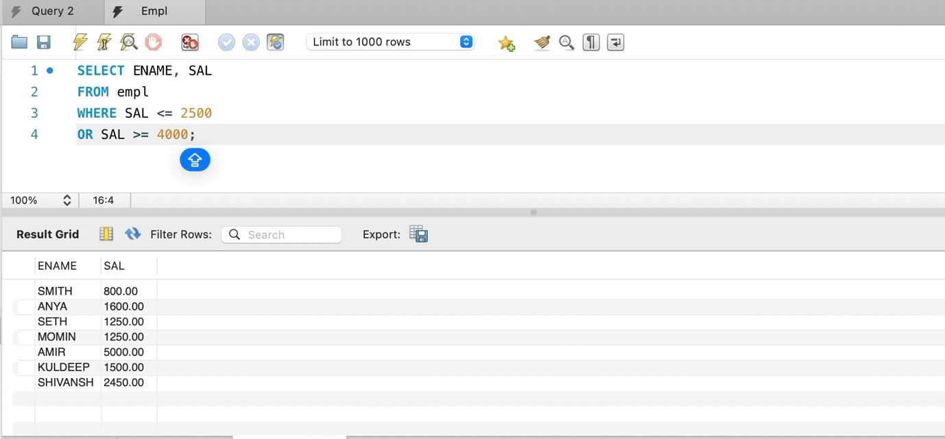

D. Write a query to display the name, job title and salary of employees who don’t have a manager?

SELECT ENAME, JOB, SAL

FROM empl

WHERE MGR IS NULL;

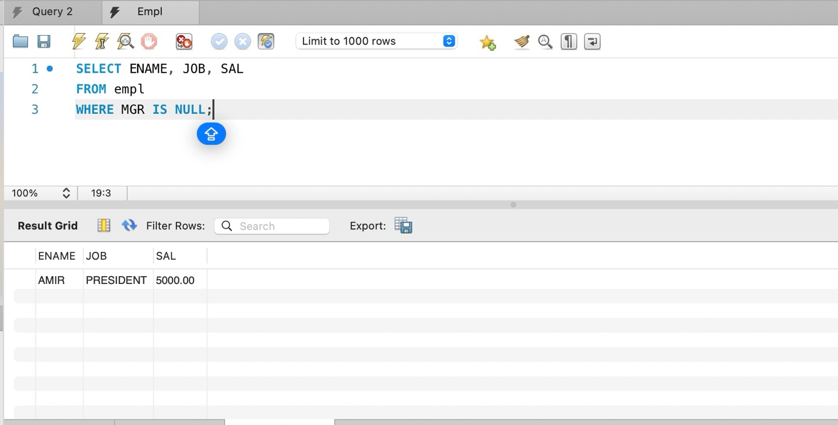

E. Write a query to display the name of an employee whose name contains “A” as third alphabet?

SELECT ENAME

FROM empl

WHERE ENAME LIKE "__A%";

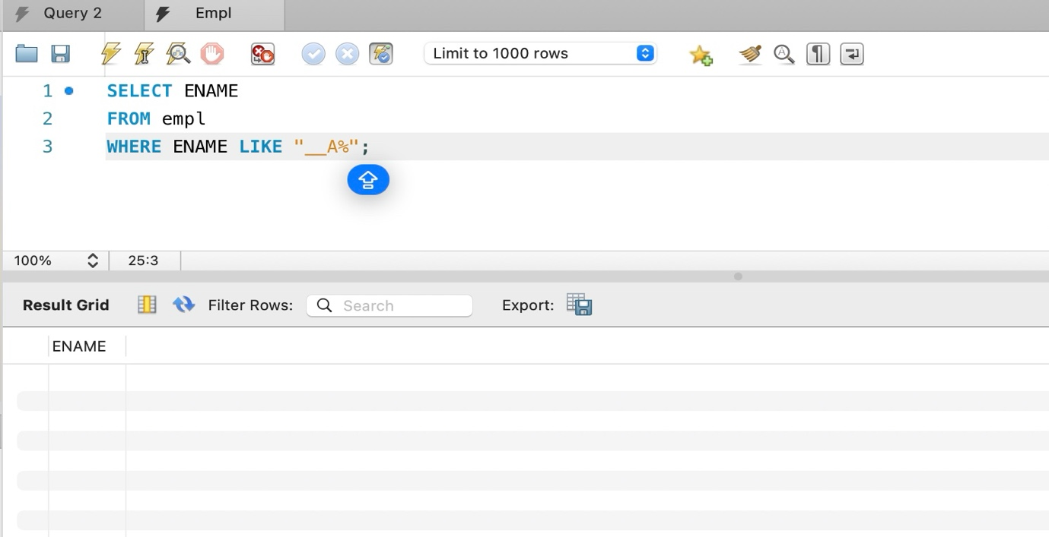

F. Write a query to display the name of an employee whose name contains”T” as the last alphabet?

SELECT ENAME

FROM empl

WHERE ENAME LIKE "%T";

